**Fault Analysis**



**Javier Jesús Macossay-Hernández**

**EE443 – Introduction to Power Systems**

**University of Southern California**

**Professor Robert Castro**

**Objective**

In power engineering, fault current is a current that passes through a short circuit, also known as fault, where it avoids the normal load. In this problem, we will be calculating the current that flows through a fault.

**Introduction**

In this problem, I will analyze the fault shown depicted in the circuit schematic below. In this circuit, the fault occurs in an unknown location on transmission line 3 and produces a fault current of 4,543.5 amperes. With the fault current given, I will find the distance from generator 4 and 5, which are at the same distance from the fault, parallel, and grounded.

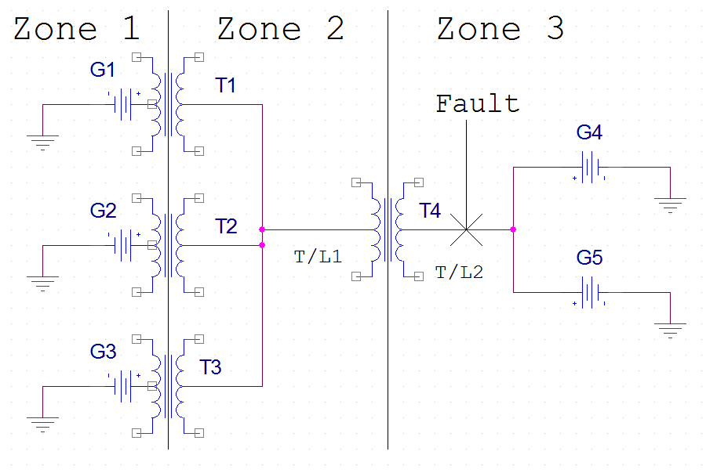

Fig. 1: The overall schematic of the circuit is shown, where the fault is in zone 3.

Data for the circuit

|  |  |
| --- | --- |
| Generators 1, 2, 3 |  |
| S – Apparent Power | 100 MVA |
| V (rated) | 345 kV |
| X (gen) | 0.05 pu |
| V (operating) | 355.35 kV |

|  |  |
| --- | --- |
| Transformer 1, 2, 3 |  |
| S – Apparent Power | 250 MVA |
| Voltage | 345 kV/ 138 kV |
| X | 0.062 pu |

|  |  |
| --- | --- |
| Transformer 4 |  |
| S – Apparent Power | 187 MVA |
| Voltage | 138 kV/ 69 kV |
| X | 0.04 pu |

|  |  |
| --- | --- |
| Generators 4, 5 |  |
| S – Apparent Power | 100 MVA |
| V (rated) | 69 kV |
| X (gen) | 0.05 pu |
| V (operating) | 71 kV |
| Short Circuit Duty | 340 MVA |

|  |  |
| --- | --- |
| T/L1 | T/L2 |
| 50 miles | 30 miles |
| j 0.6 ohm/mi | j 0.6 ohm/mi |

**Methods**

Approach

1. I will begin my fault analysis by setting the base MVA for the circuit, creating the zone, and setting the base kV in each zone.
2. Find the base impedances and currents for each zone.
3. Then, I will find the new impedances after I set the base value for MVA and kV.
4. I will then use the short circuit duty given in the diagram to find the system reactance of generator 4 and 5.
5. With the impedances I found, I will simplify the circuit to create the impedance of transmission line 2 as a variable.
6. After finishing the impedance diagram, I will change the given fault current, 4,035 amperes, to a per unit value. Finally, I will find the distance between generator 4 and 5 and the fault.

Solution

I will choose my base MVA value equal to 100 MVA because that is the value of the generators.

**Calculations**

Zone 1-

SB= 100 MVA

VB= 345 kV

S = sqrt(3)*IBV → IB = = = = 167.348 A

ZB = VB2/SB = = Ω = 1190.25 Ω

Zone 2-

SB= 100 MVA

VB = 345 kV ( $\frac{138 kV}{345 kV})$ = 138 kV

IB = = = = 418.37 A

ZB = VB2/SB = = Ω = 190.44 Ω

Zone 3-

SB = 100 MVA

VB = 138 kV ($\frac{69 kV}{138 kV}$) = 69 kV

IB = = = = 836.74 A

ZB = VB2/SB = = Ω = 47.61 Ω

Now, I will calculate the new impedances.

Xnew = Xold )2 )

Xg1 = Xg2 = Xg3 = (0.05) (2 ) = 0.05 pu

XT1 = XT2 = XT3 = (0.062))2 ( = 0.0248 pu

XT4 = (0.04))2 ( = 0.0214 pu

Xg4 = Xg5 = (0.05) (2 ) = 0.05 pu

Now, I will solve for the transmission line 1 and get the per unit impedance.

ZT/L1actual = (50 miles)( $\frac{j0.6 ohms}{1 mile})$ = j30 Ω

ZT/L1actual = (ZT/L1pu)(ZT/L1base)

where ZT/L1base  = Zbase2 = 190.44 Ω

ZT/L1pu =

= j0.158 pu

The impedance in transmission line 2 is divided into two because the fault occurs in that transmission line. The distance between the transformer 4 and the fault is “x” and between the generators 4 and 5 and the fault is “30 – x” (the total length of the transmission line 2 is 30 miles). Therefore, I will find the two impedances.

ZT/L1actual(x) = (x miles)( $\frac{j0.6 ohms}{1 mile})$ = j0.6x Ω

ZT/L1actual(30-x) = (30 - x miles)( $\frac{j0.6 ohms}{1 mile})$ = 18 - 0.6x jΩ

ZT/L2actual = (ZT/L2pu) (ZT/L2base)

where ZT/L2base  = Zbase3 = 47.61 Ω

ZT/L2pu =

x impedance

ZT/L2pu = = j0.013x pu

30 - x impedance

ZT/L2pu = = j0.378 pu - 0.013x pu

I will determine the system reactance of generator 4 and 5 with the value of the short circuit duty and using the voltage value in zone 3.

SDuty = sqrt(3)*ISCV

IB = = = 2,844.91 A

Current of the short circuit = 2,844.91 A

Now, I have two equations to solve for three phase voltage (Vφ). Vφ = (ISC)(Xsystem), where Xsystem is the impedance of the system.

I will use the following formula to solve for Vφ and, then, I will solve for the impedance of the system:

Vφ = $\frac{V }{sqrt(3)}$

Vφ = $\frac{69 kV }{sqrt(3)}$ = 23 $\sqrt{3}$ kV= 39, 837.2 V

Xsystem = Vφ/ISC = = 14.0029 Ω

In order to do the impedance diagram, I will have to find the system reactance in a per unit value. I will use the base reactance of zone 3, 47. 61 Ω.

Zsys, actual = (Zsys, pu) (Zsys,base 3)

Zsys, pu = = = 0.29412 pu

Generators 1, 2, and 3 do not have a system reactance because they do not have a short circuit duty. Now, I can do the impedance diagram since I have calculated all the impedances.

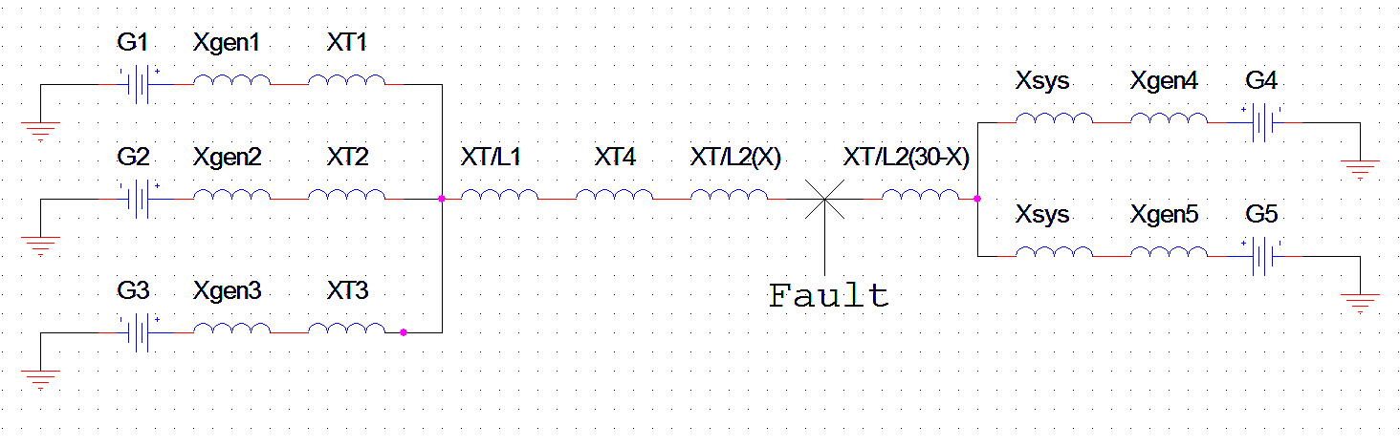

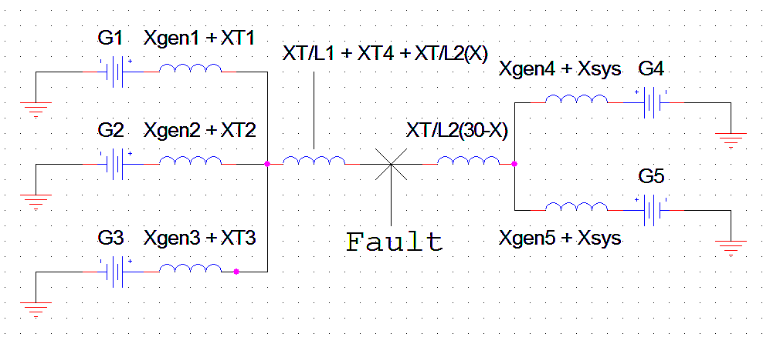

Xg1 + XT1= Xg2 + XT2 = Xg3 + XT3 = 0.05 pu + 0.0248 pu = 0.0748 pu

XT/L1 + XT4 + XT/L2(x) = 0.158 pu + 0.0214 pu+ 0.013x pu= 0.1794 pu + 0.013x pu

Xg4 + Xsys = Xg5 + Xsys = 0.05 pu + 0.29412 pu = 0.34412 pu

I can add the parallel impedance and since the generators in parallel have the same voltage, it will not affect my result.

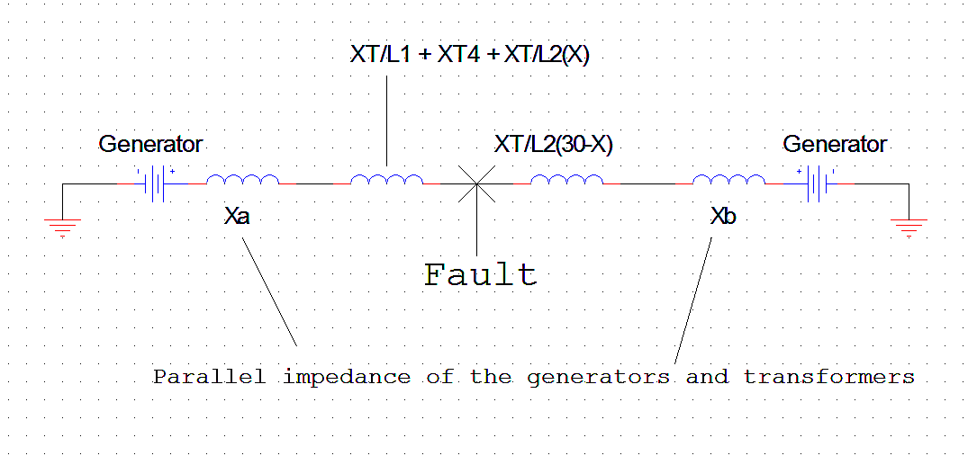

Calculating impedance XA

Xg1 + XT1 || Xg2 + XT2 || Xg3 + XT3 = XA = + + )-1 = 0.0249 pu

Calculating impedance XB

Xg4 + Xsys || Xg5 + Xsys = XB = + )-1 = 0.17206 pu

Now, I can simplify the impedance diagram more.

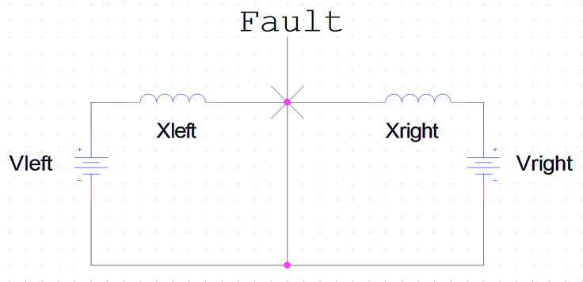

Calculating Xleft

XA + XT/L1 + XT4 **+** XT/L2(x) = 0.0294 pu + 0.1794 pu + 0.013x pu = 0.2088 pu + 0.013x pu

Calculating Xright

XB + XT/L2(30 – x) = 0.17206 pu + 0.378 pu - 0.013x pu = 0.5506 pu - 0.013x pu

I need to find the per unit value of the voltages of the two generators in order to find the fault current, make it equal to the per unit voltage divided by the per unit impedance, and, finally, solve for the distance “x.”

Vleft

Vpu = = = 1.03 pu

Vleft

Vpu = = = 1.03 pu

Since Ipu = = +

and Ipu =

Therefore, $\frac{Iactual fault}{I base 3}= \frac{Vleft, pu}{jXleft, pu}$ + $\frac{Vright, pu}{jXright, pu}$

Now, I just can plug in the numbers and solve for the distance “x.”

I actual fault = 4,543.5 amperes

I base 3 = 836. 74 amperes

Therefore, Ipu = 5.43 pu

$\frac{Vpu}{jXpu}$ = $\frac{1.03 pu}{0.2088pu+0.013x pu}$ + $\frac{1.03 pu}{0.5506pu-0.013x pu}$

Numerator-

1.03(0.5506 - 0.013x) + 1.03(0.2088 + 0.013x)

= 0.567118 – 0.01339x + 0.215064 + 0.01339x

=0.782182 pu

Denominator-

(0.2088 + 0.013x)(0.5506 – 0.013x)

= 0.114965 – 0.002714x + 0.007158x – 0.000169x2

= -0.000169x2 + 0.004444x + 0.114965

Therefore, 5.43 = $\frac{0.782182}{-0.000169x^{2}+0.004444x+0.114965}$

(-0.000169x2 + 0.004444x + 0.114965)(5.43)

= -0.000918x2 + 0.024131x + 0.62426

0.782182 = -0.000918x2 + 0.024131x + 0.62426

0.000918x2 – 0.024131x – 0.62426 + 0.782182

0.000918x2 – 0.024131x + 0.157922 = 0

a = 0.000918, b = -0.024131, c = 0.157922

Now, I will solve for x using a quadratic equation

x = $\frac{-b ±{\left(b^{2}-4ac\right)}^{1/2}}{2a}$

**Results**

x =

x =

x1 = 13.14 miles

x2 = 13.14 miles

x1 = x2

Distance from generator

30 - 13.14 = 16.86 miles

**Discussion**

After applying the concepts of short circuit duty, per unit calculations, and impedance diagrams, I found that the fault was located 16.86 miles from generator 4 and 5 or 13.14 miles from transformer 4.